**Unit Testing**

1. **Register for Applicant**

This create_users_table function is used to make an users table in the microhousing database and declare each variable which will be used for the register applicant.

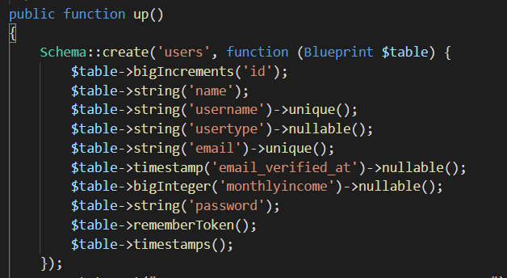

This registerContoller function is use to validate input from user when registering as an Applicant to the DBKL Microhousing. If applicant input invalid information the system will not accept the information and display an error from invalid input from the applicant.

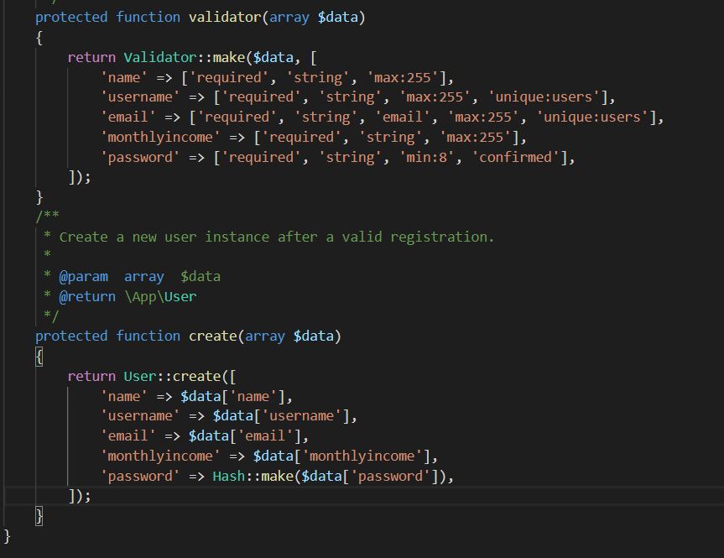

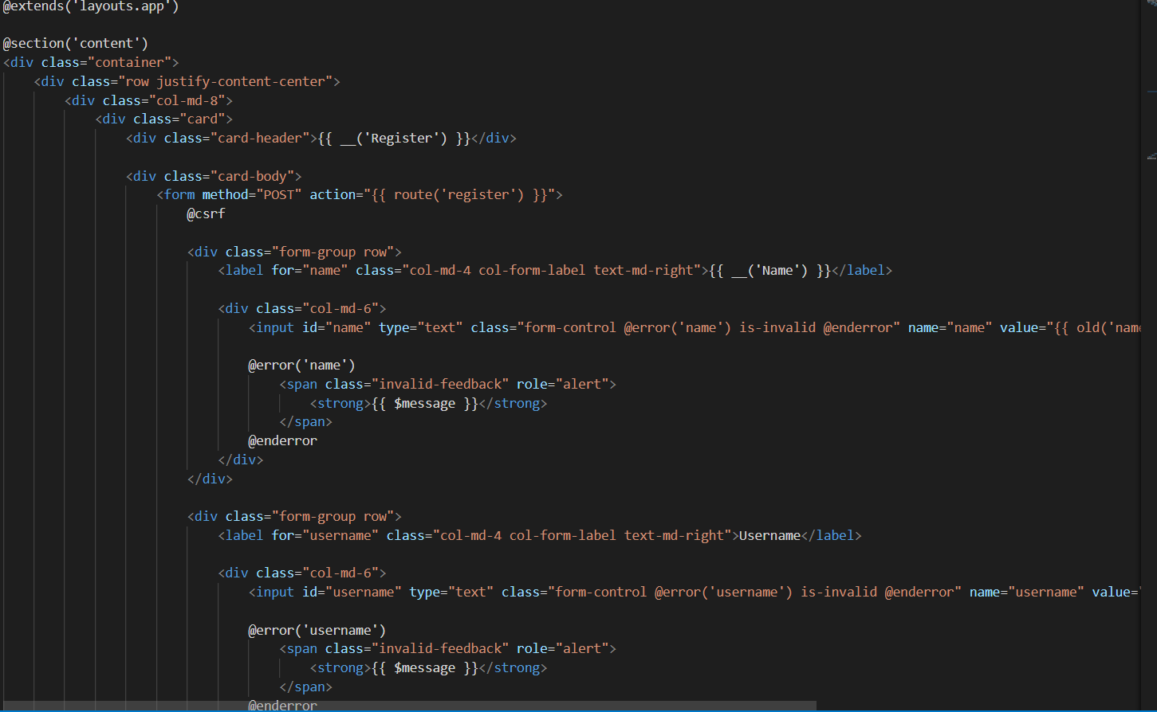

This $fillable is register the attribute (column name) that we can fill in when inserting or updating to the database.

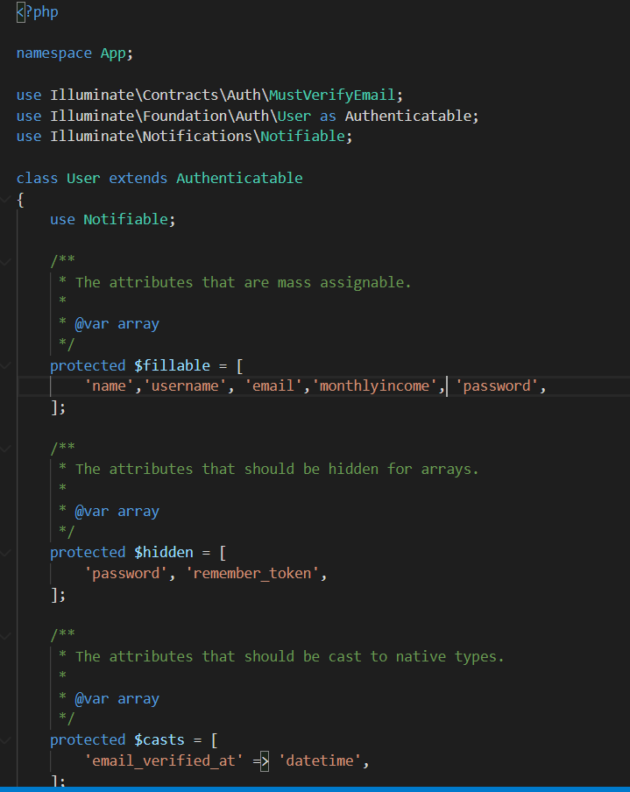

1. **Applicant input blank information**

The required rule function was complete successfully.

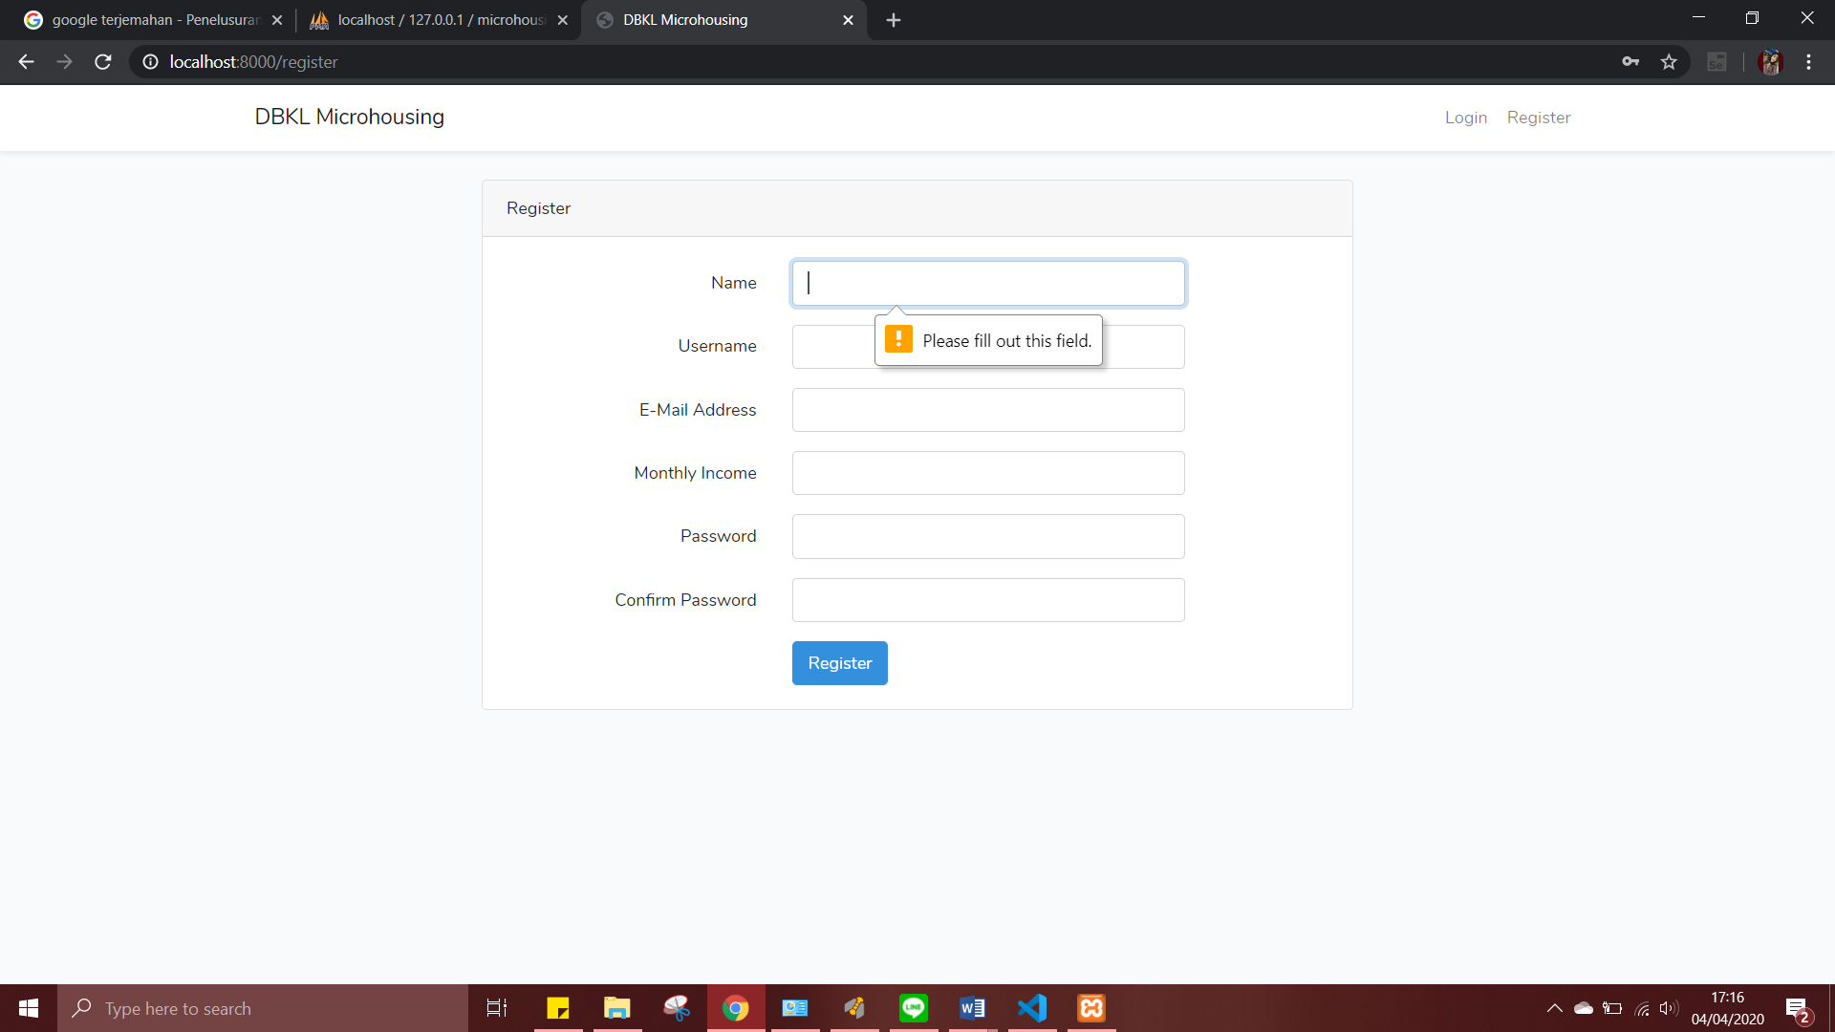

1. User input wrong email or username (username already in the database / not unique) unique() function is for username and email was complete successfully.

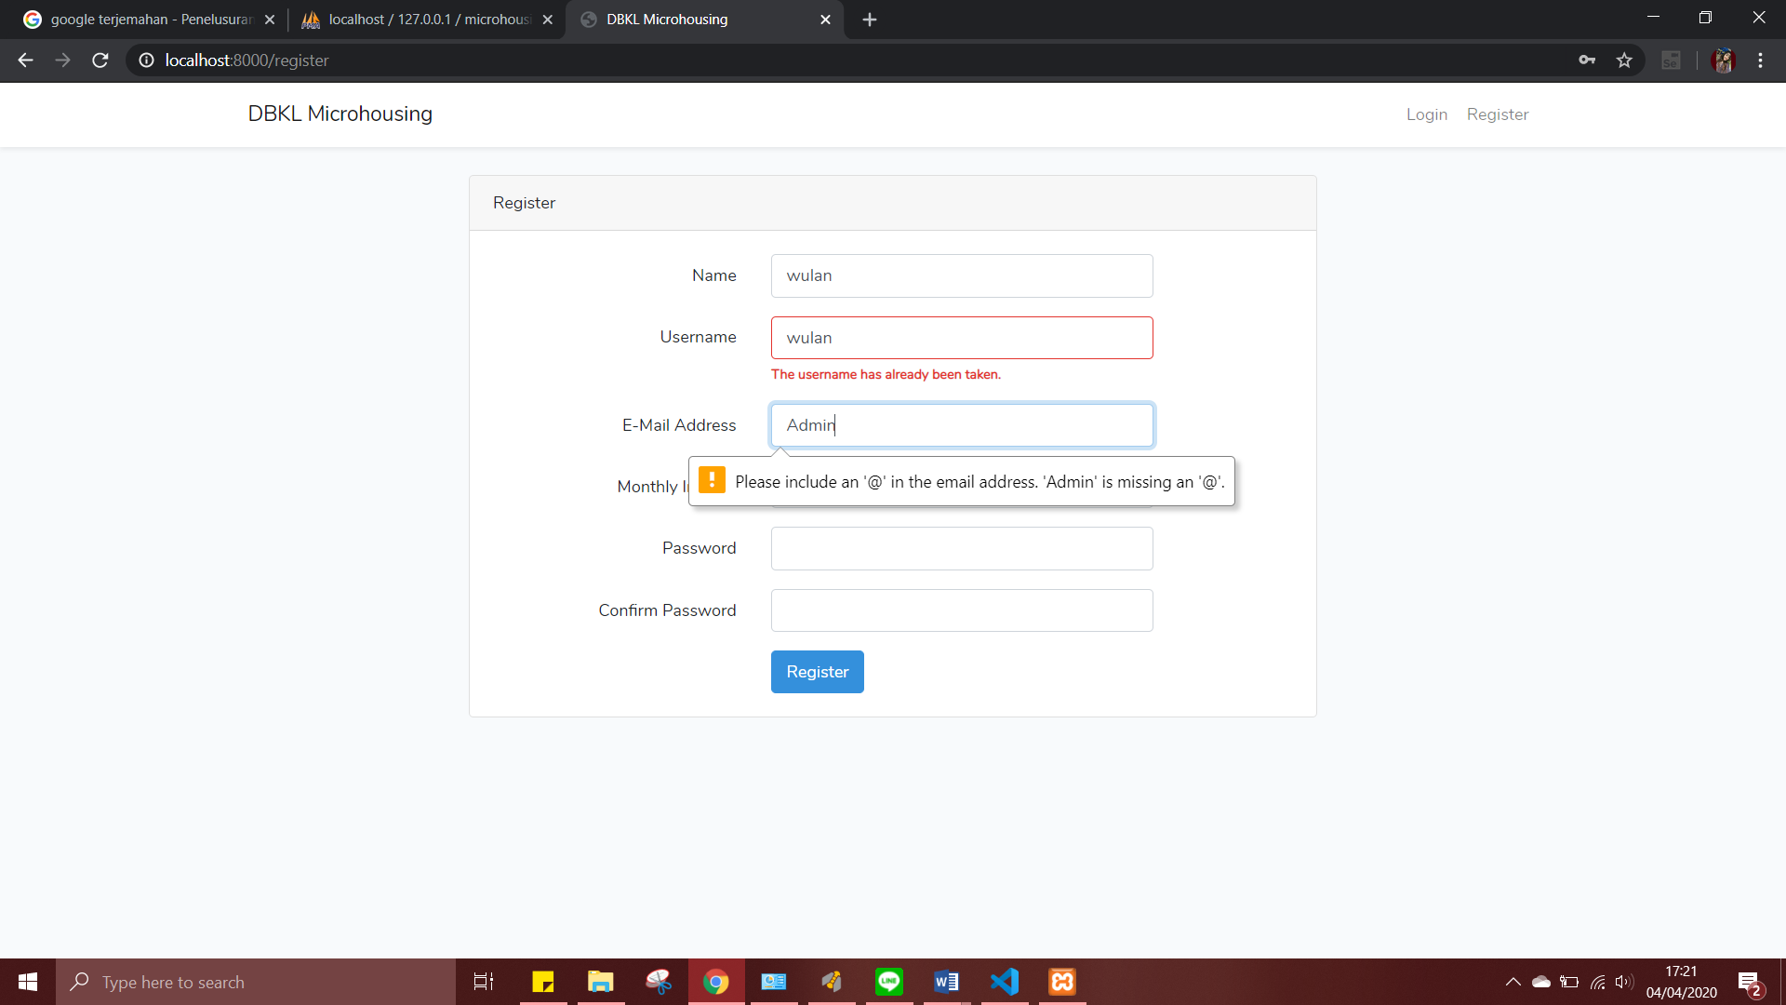

1. Applicant input invalid email and password (too short) class email and password that has class for display error which is @enderror were complete successfully.

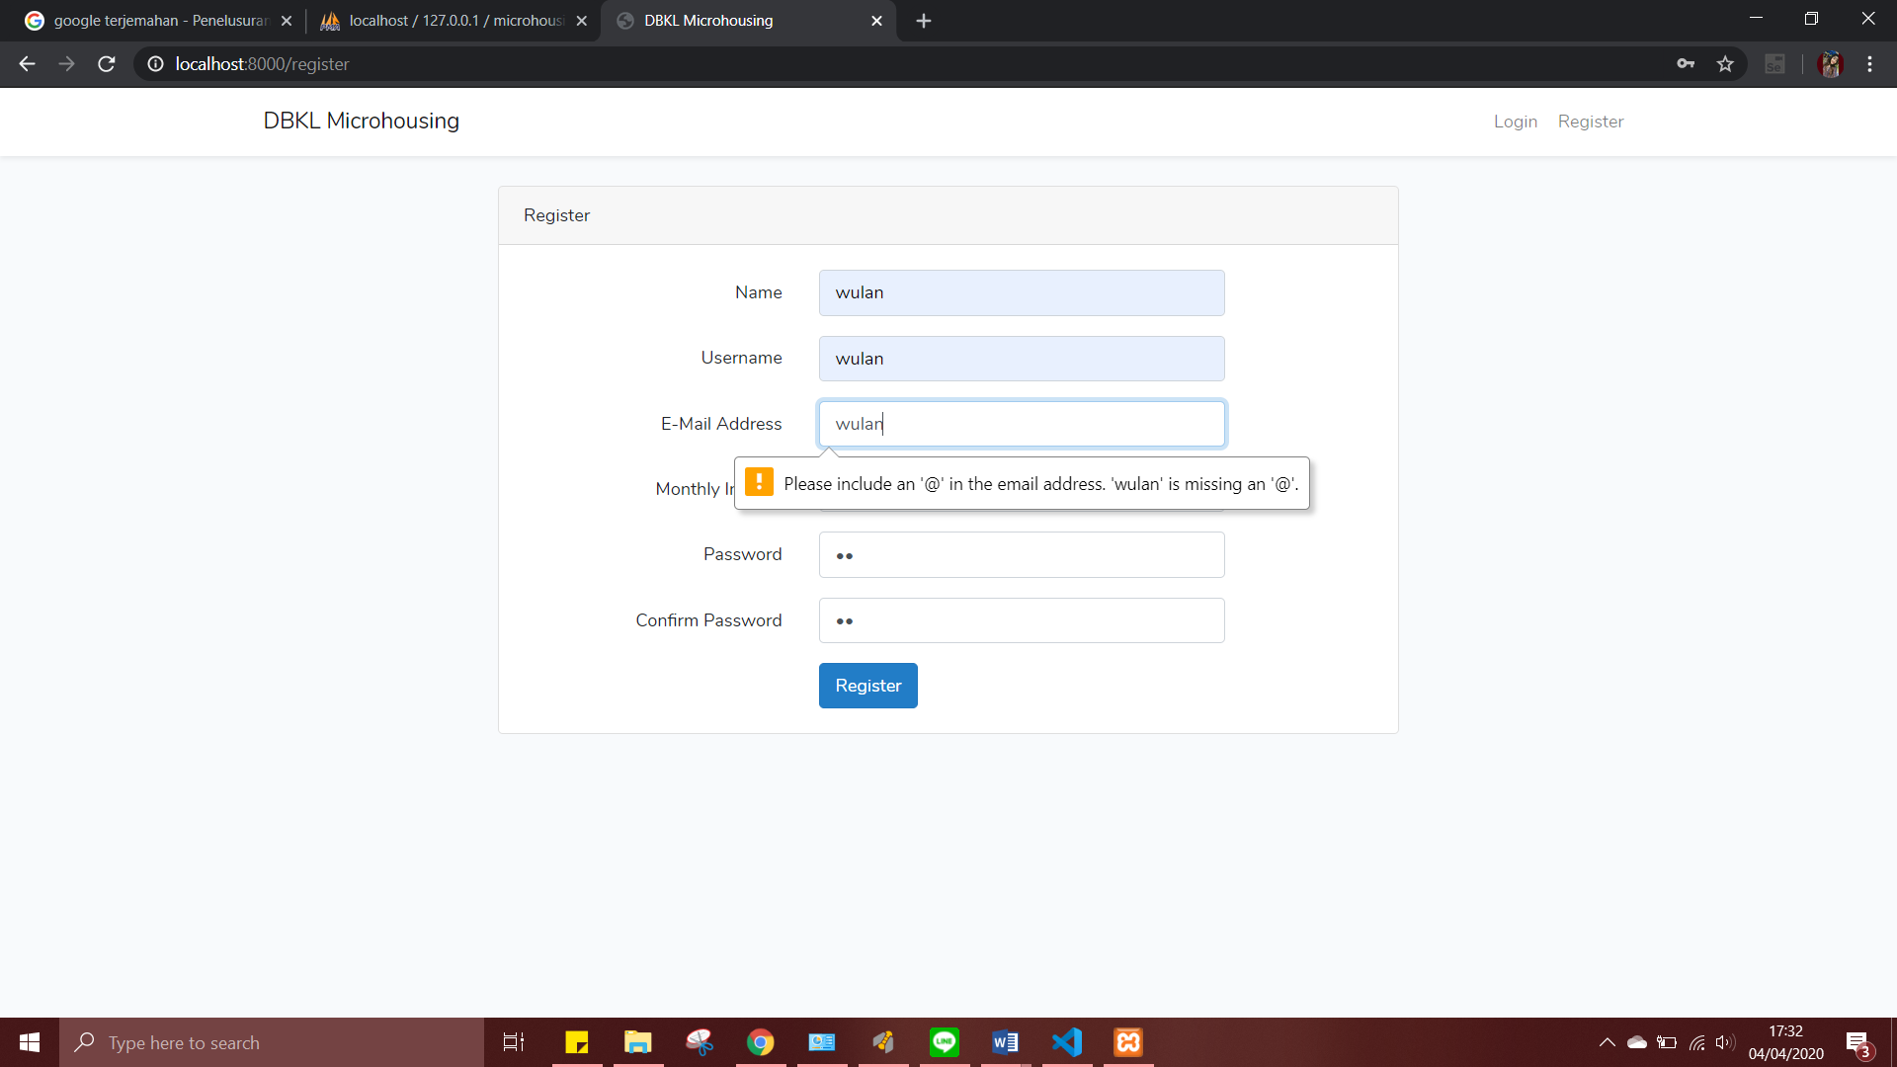

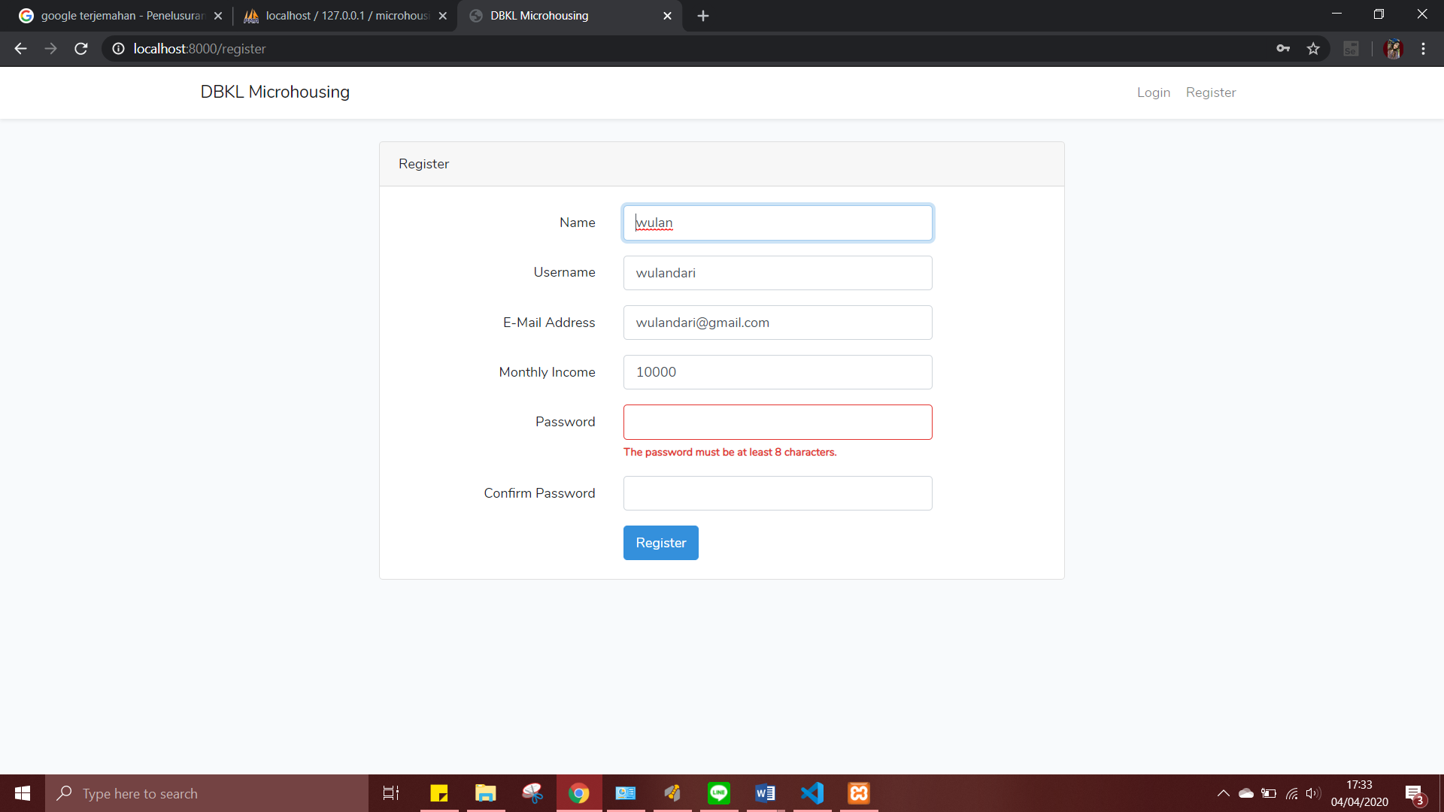

If applicant input valid information, the system will enter the applicant’s information to the database ‘microhousing’ automatically.

1. Password Hashing

When register, the applicant’s password will be saved in the database, and the password will be hashed so that won't be easy to read by others.

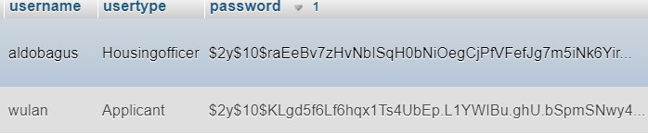

1. **Login**

This loginController function is to validate and separated according to the role as housing officer and as applicant which is will be input manual in usertype (to directed each web page).

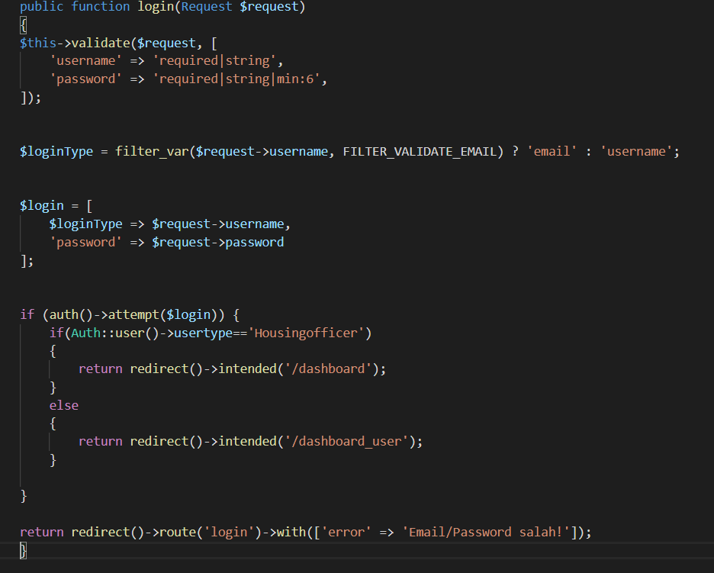

This function to make a form for login and the input will be verified whether it is in the database.

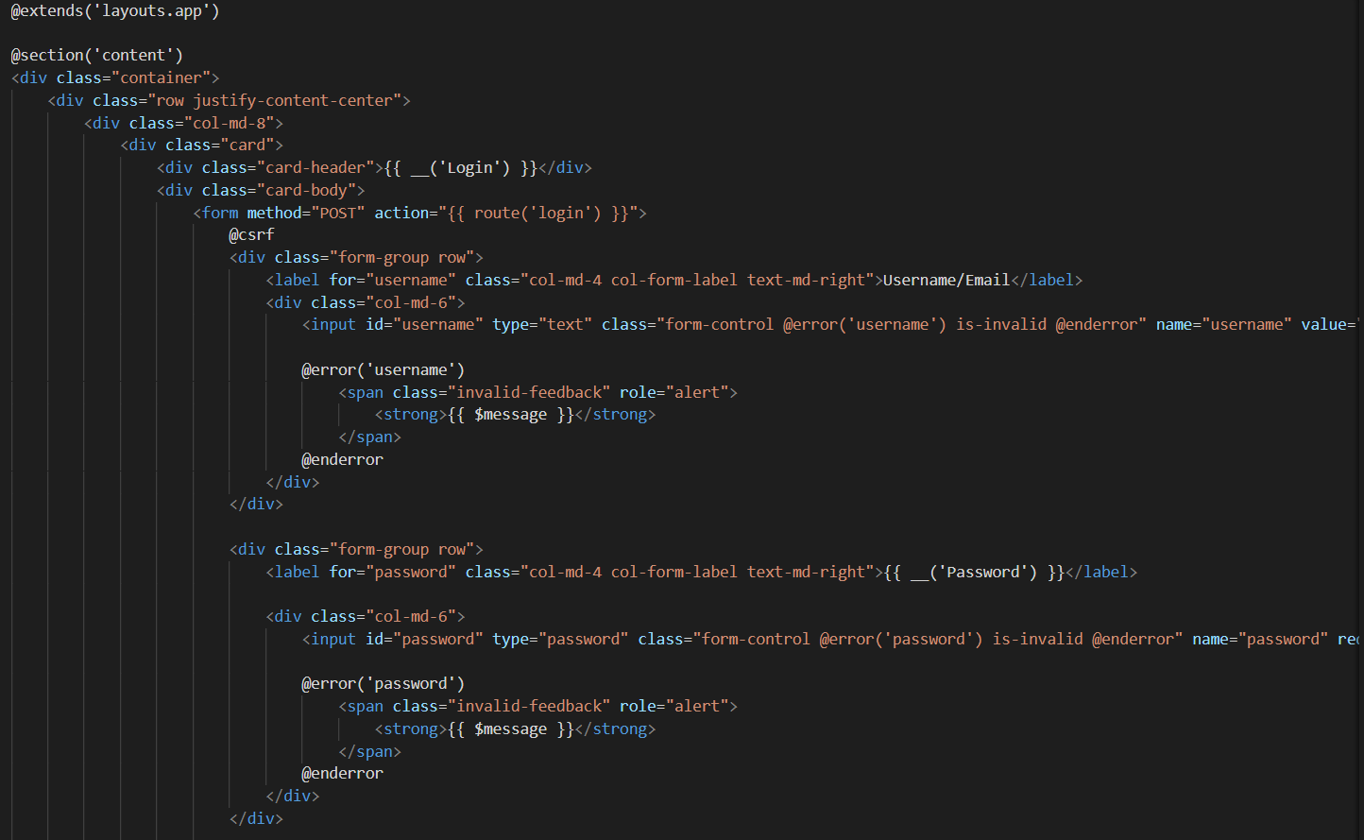

User input invalid username and password, the system will not response and will stay in the login page

User input valid username and password, the system will checking into the database and each user will be direct to their dashboard according to their role.

Applicant Homepage



Housing Officer Homepage

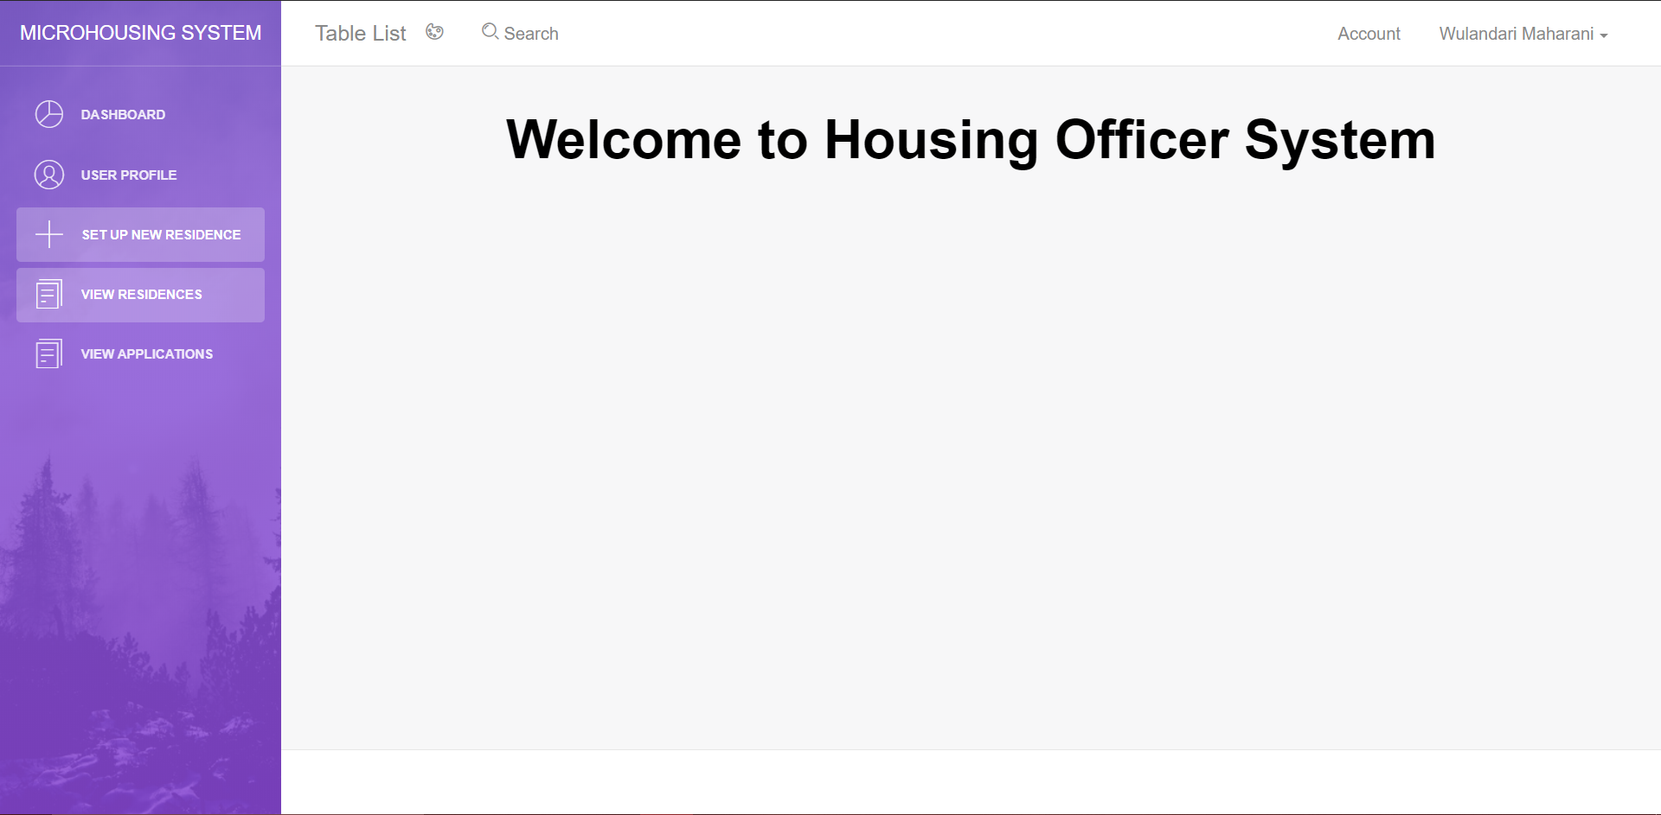

1. **LogOut**

This nav bar will delete the user session which is allocate in master.blade.php. so the website cannot access user information again. If this function is remove, so the user will return to the dashboard login page.

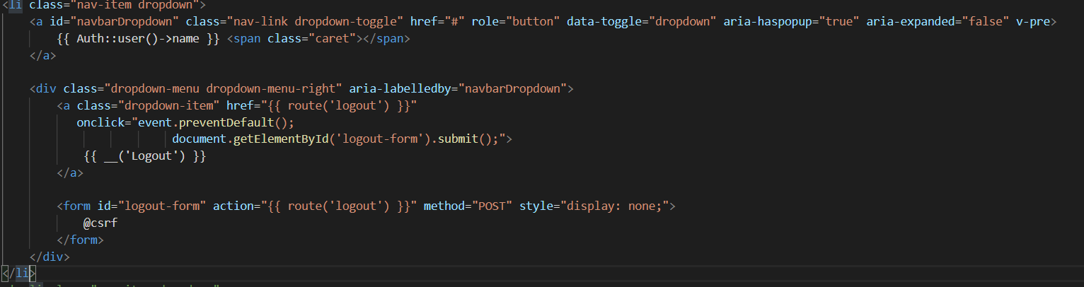

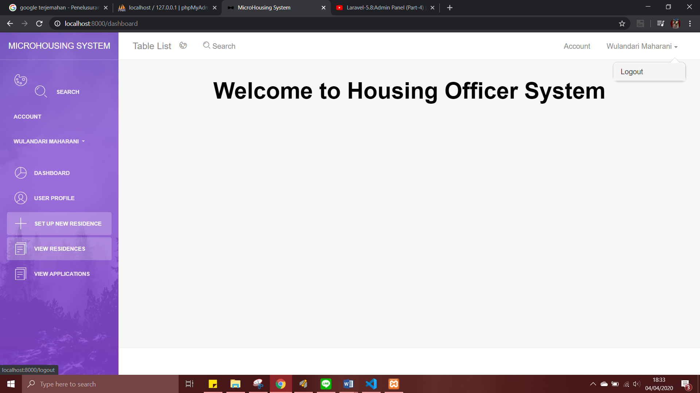

Back to dashboard page



1. **Set Up New Residence**

In this test, the set up new residence will be able to add residence and each variable will input to ‘microhousing’ database in residence table.

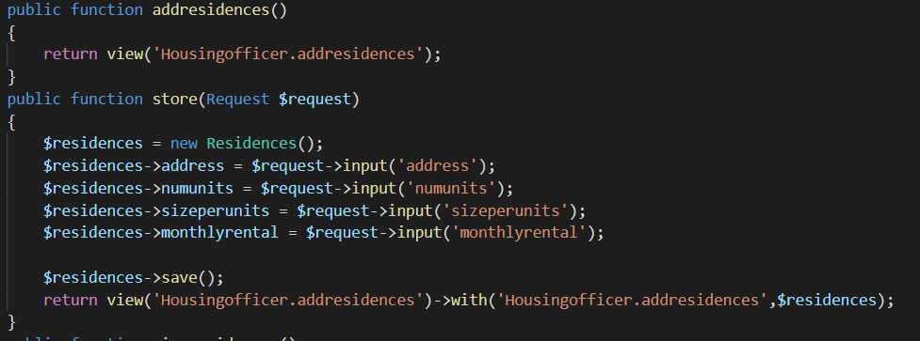

This addresidence.blade.php which is form to input the data

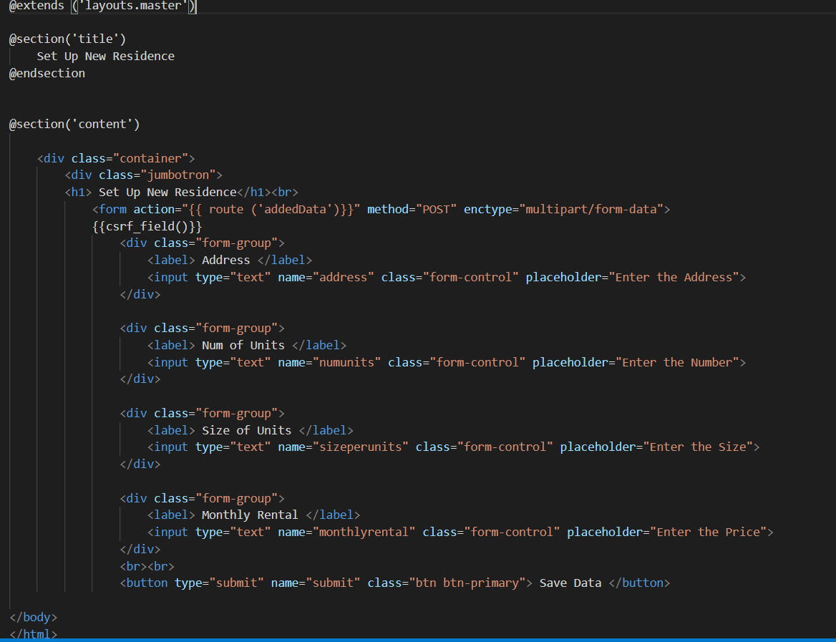

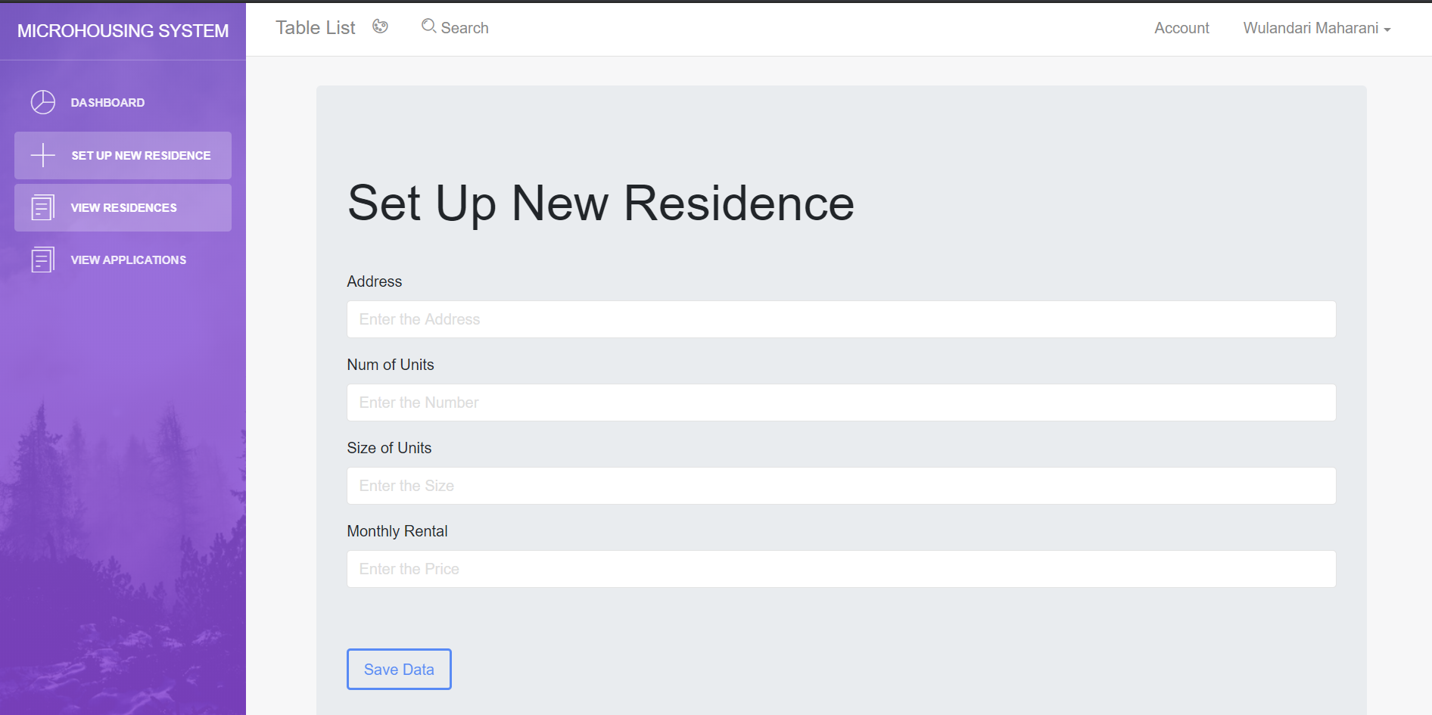

1. **View Residence Detail**

This test, viewresidence.blade.php function runs properly, displaying all the residence in the database. Residence data in the database will be stored in row that is will be send to the housingofficer’s page.

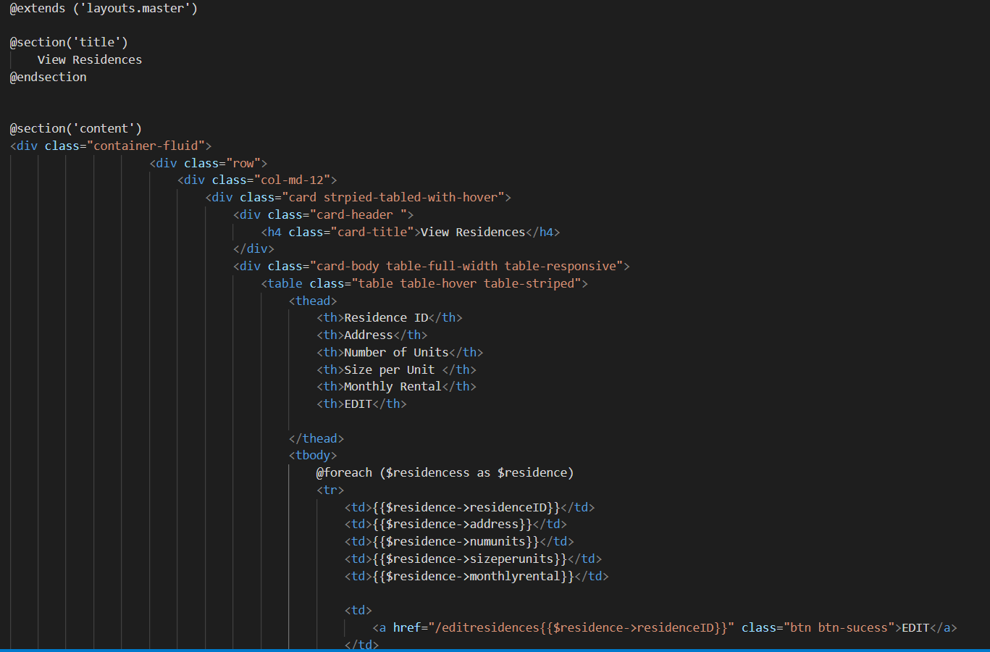

This function to call all the residence which has been inputted and store in the database.

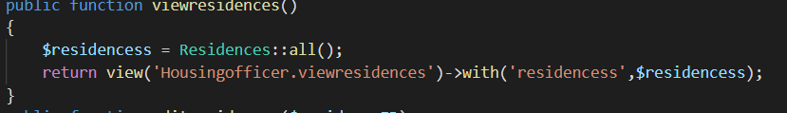

This is the residence data in ‘microhousing’ database.

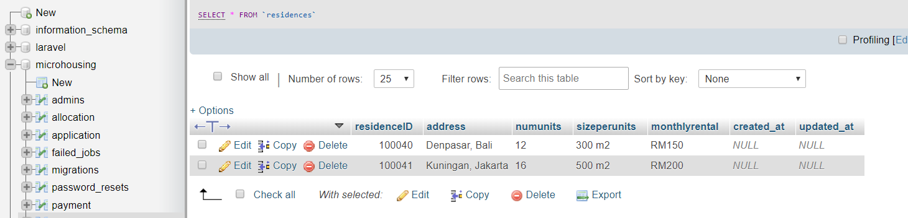

The view residence in the housing officer page

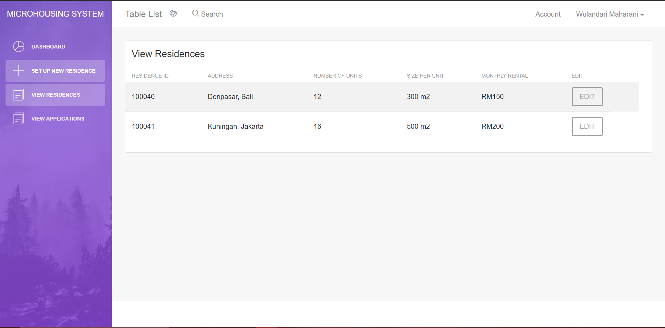

1. **Edit Residence Detail**

In this test will editresidence.blade.php function runs properly. This function useful for editing the residence, which is already input. For editing we need ‘Model’ that will receive data input from the residence model and then update the data into the database.

This is the Residence.model

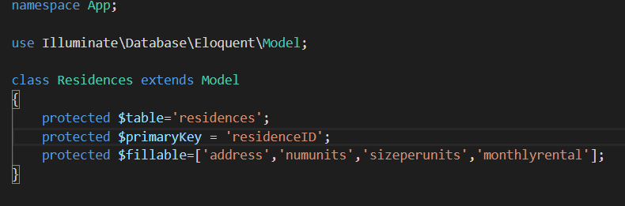

This function is to find the residenceID because when we want to edit every residence has edit button so we will find the residenceID.

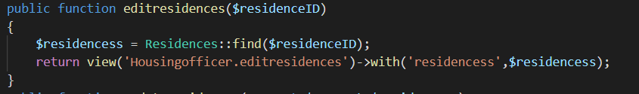

This is the editresidence.blade.php is form for the edit residence.

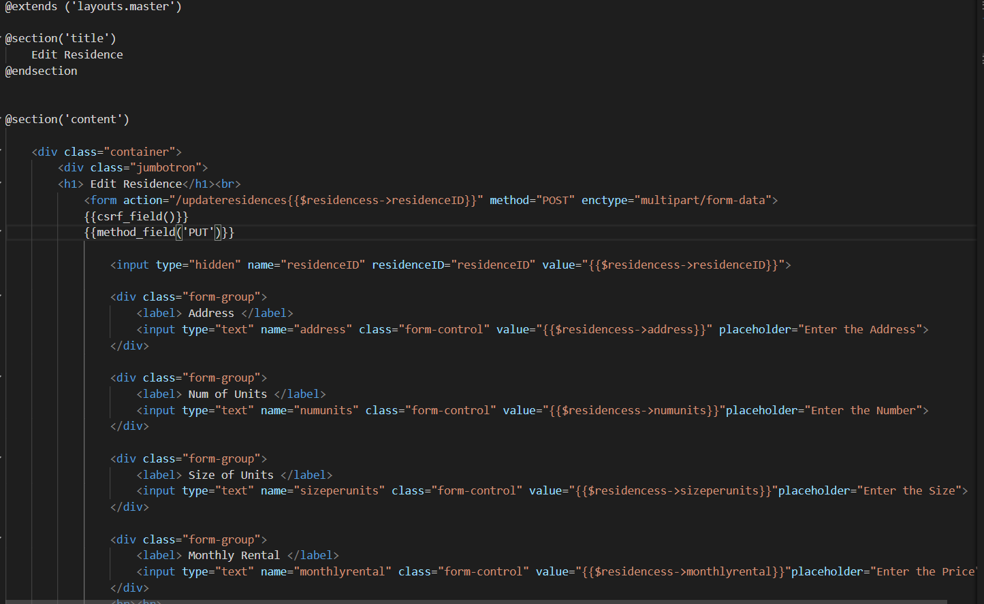

This this display form edit residence

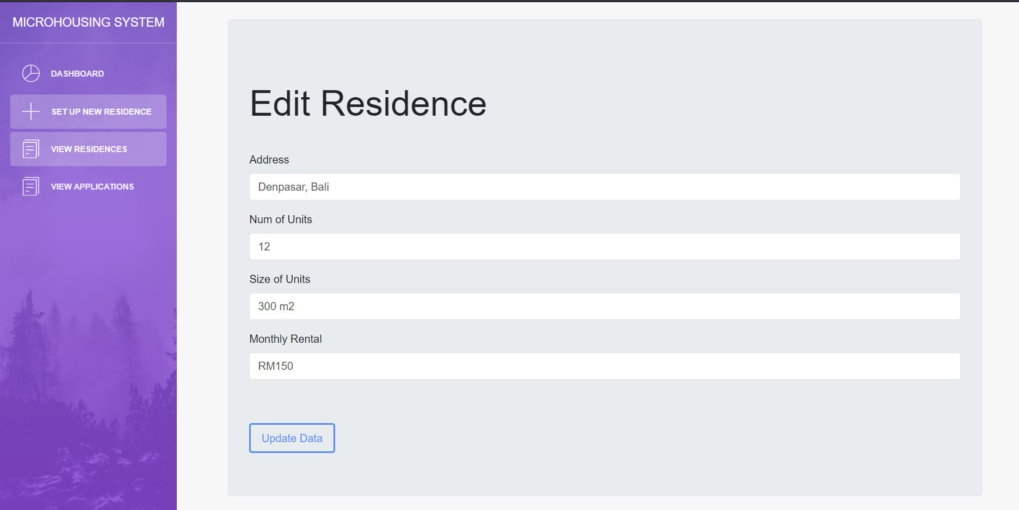

1. **View Applications**

This test, viewapplication.blade.php function runs properly, the applications are displayed in the view application menu for Housing Officer menu, are applications that related to the residence.

This is the form for the view application and the button for delete and allocate but not functioning yet

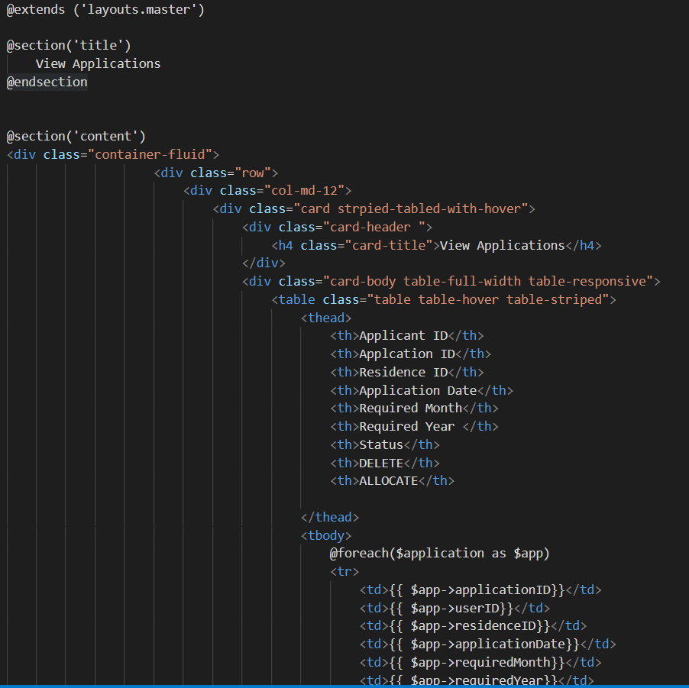

This function is to call the table application in the database, which is input by the applicant

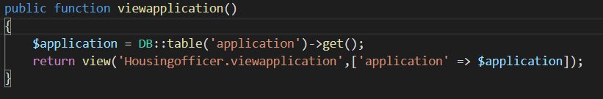

This display for view applications from input by applicant

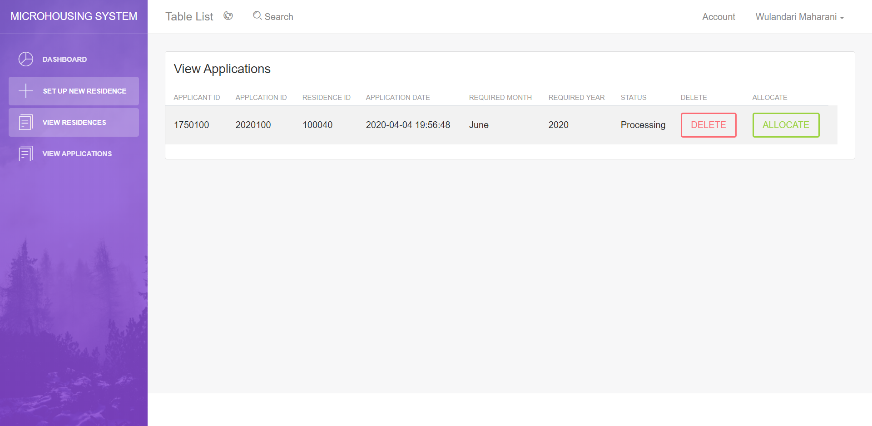

1. **Submit Application**
2. **View Residence (Applicant)**

In this test, viewresidence.blade.php which is the folder function runs properly, displaying all the residence which is input by the housing officer and all the residence data in the database.

This is form for the view residence in the applicant role

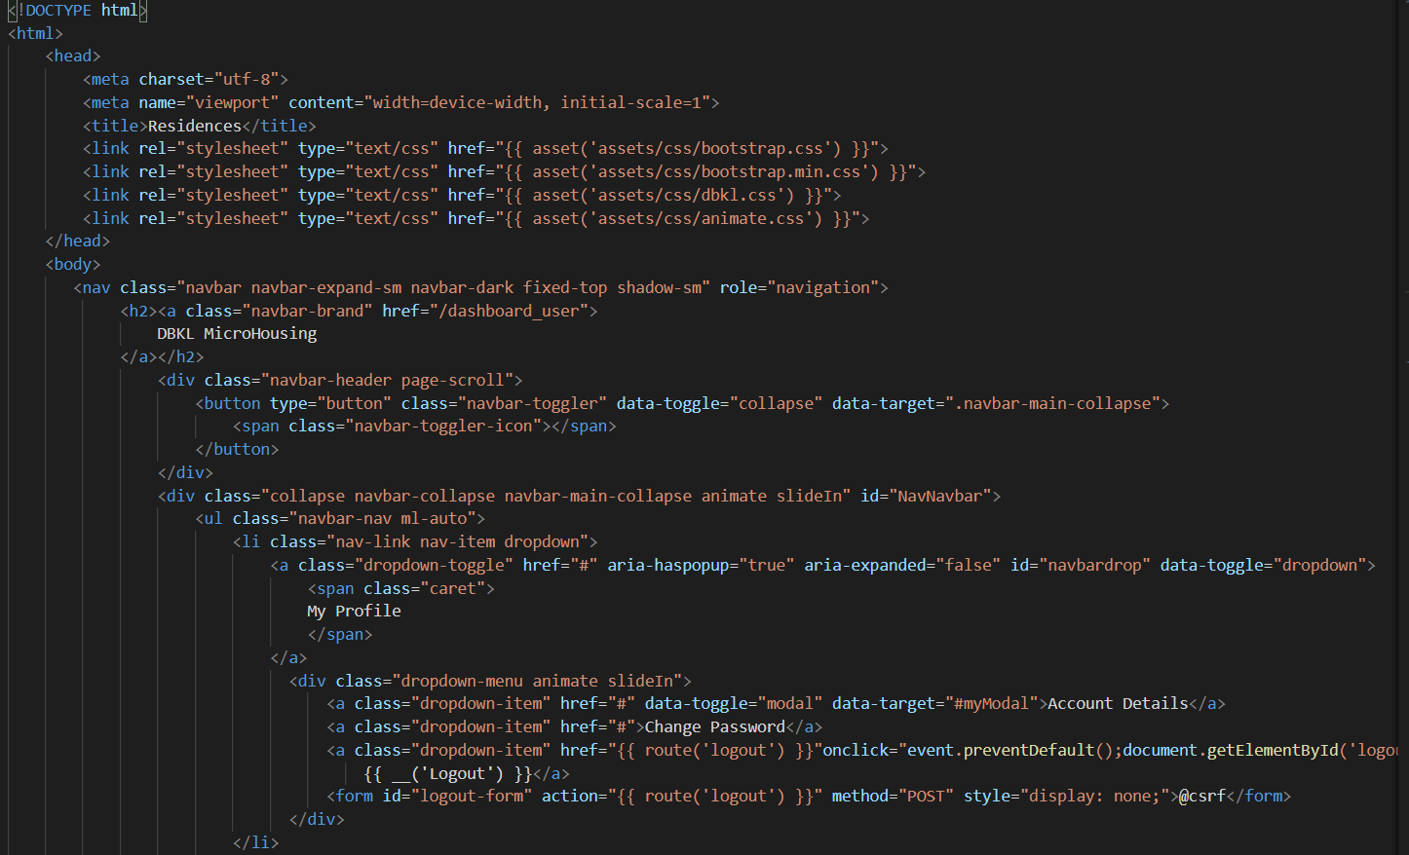

This function is to call the table application record in the database

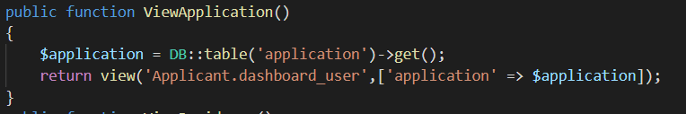

This is display submit application page

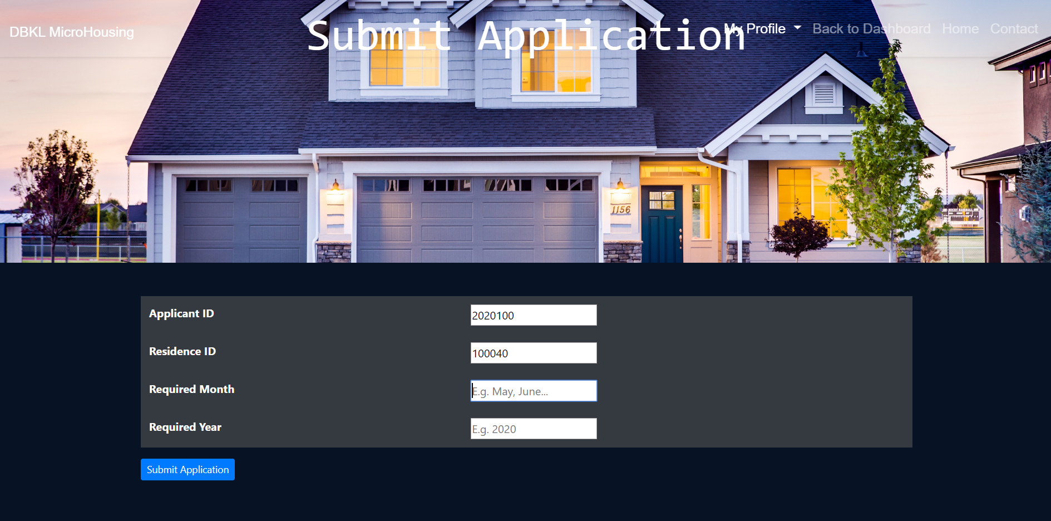

If the applicant input invalid information that is required month and required year (Not fill), the system will display an error.

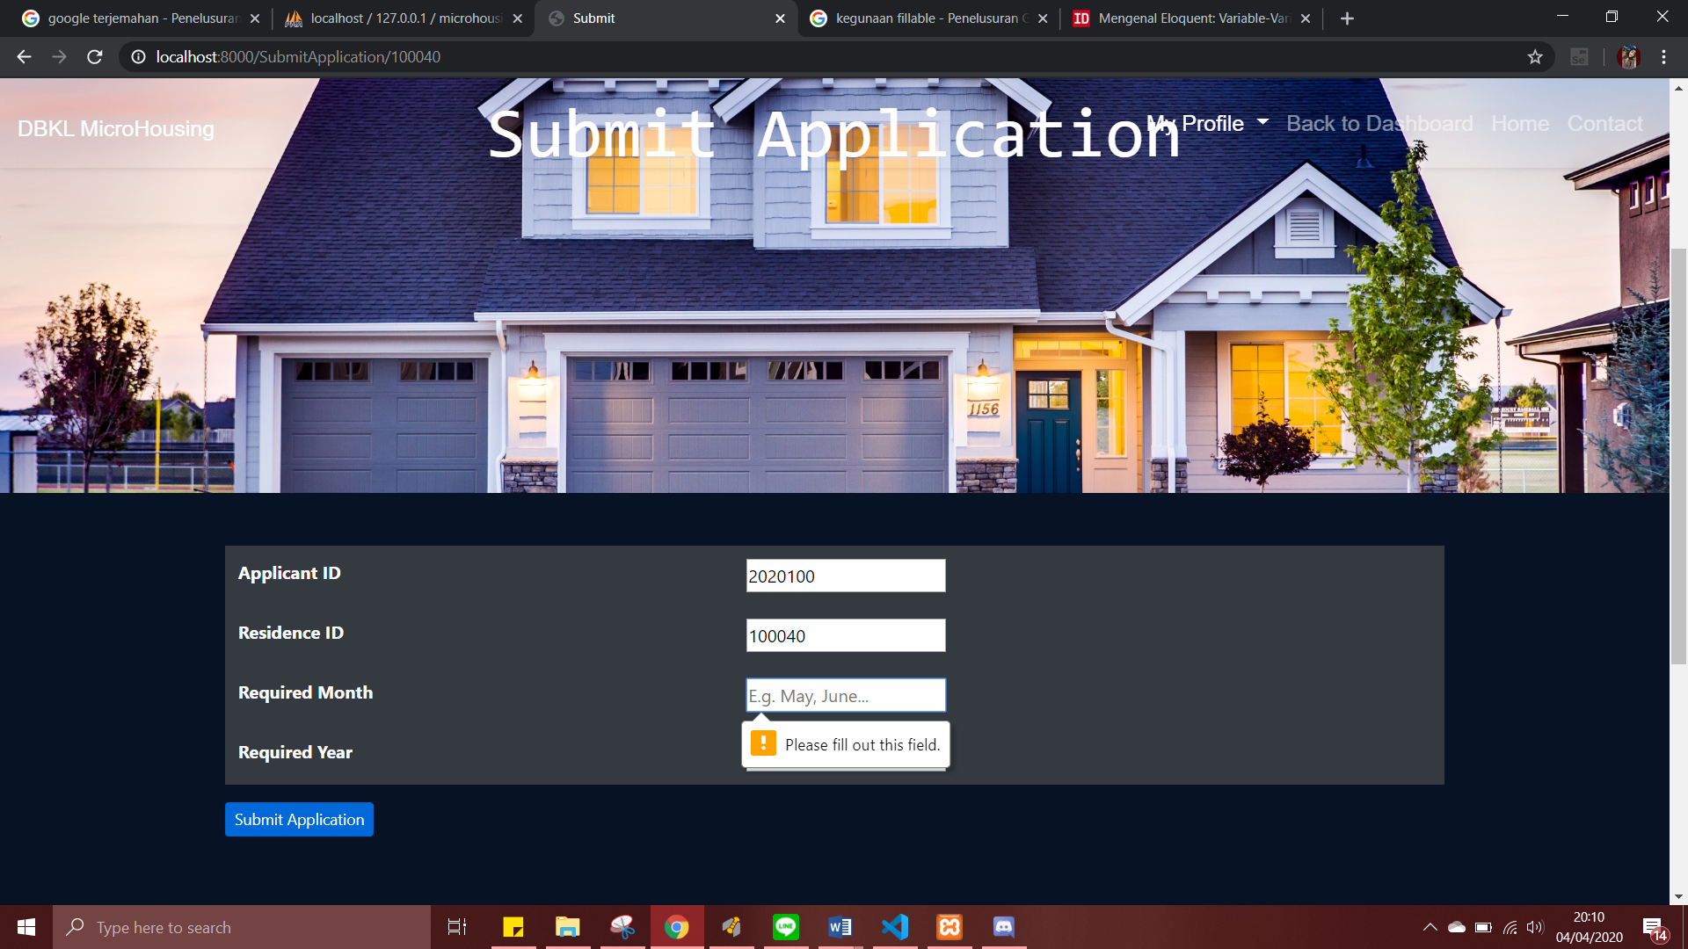

1. **View Application**

This test ensure the applications that are display the viewapplication which is the function in the applicant folder. The applicantcontroller functioning properly. In this code the applicantID will be login first, the the applicant id will look for, and the application will display the application that has the same applicantID thas has login

This is the form table will be display in the applicant dashboard

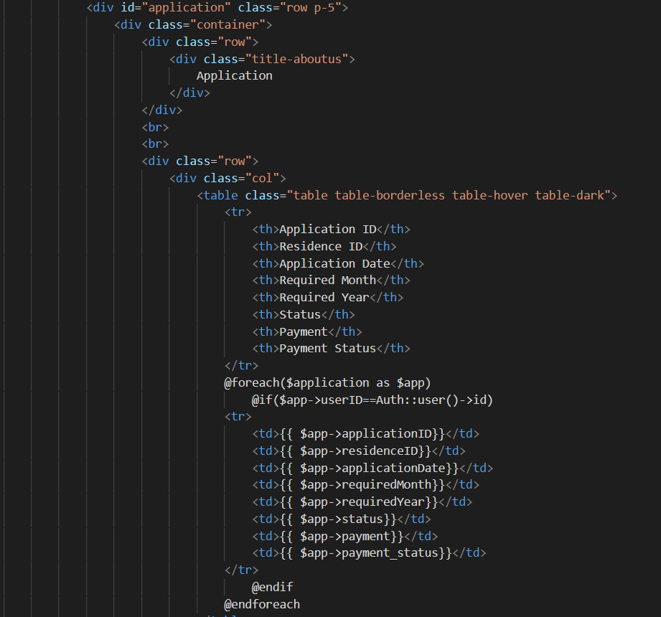

This function is to call the applications which is in the database and already input by the applicant.

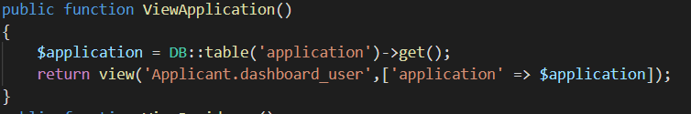

This display the application which is already input

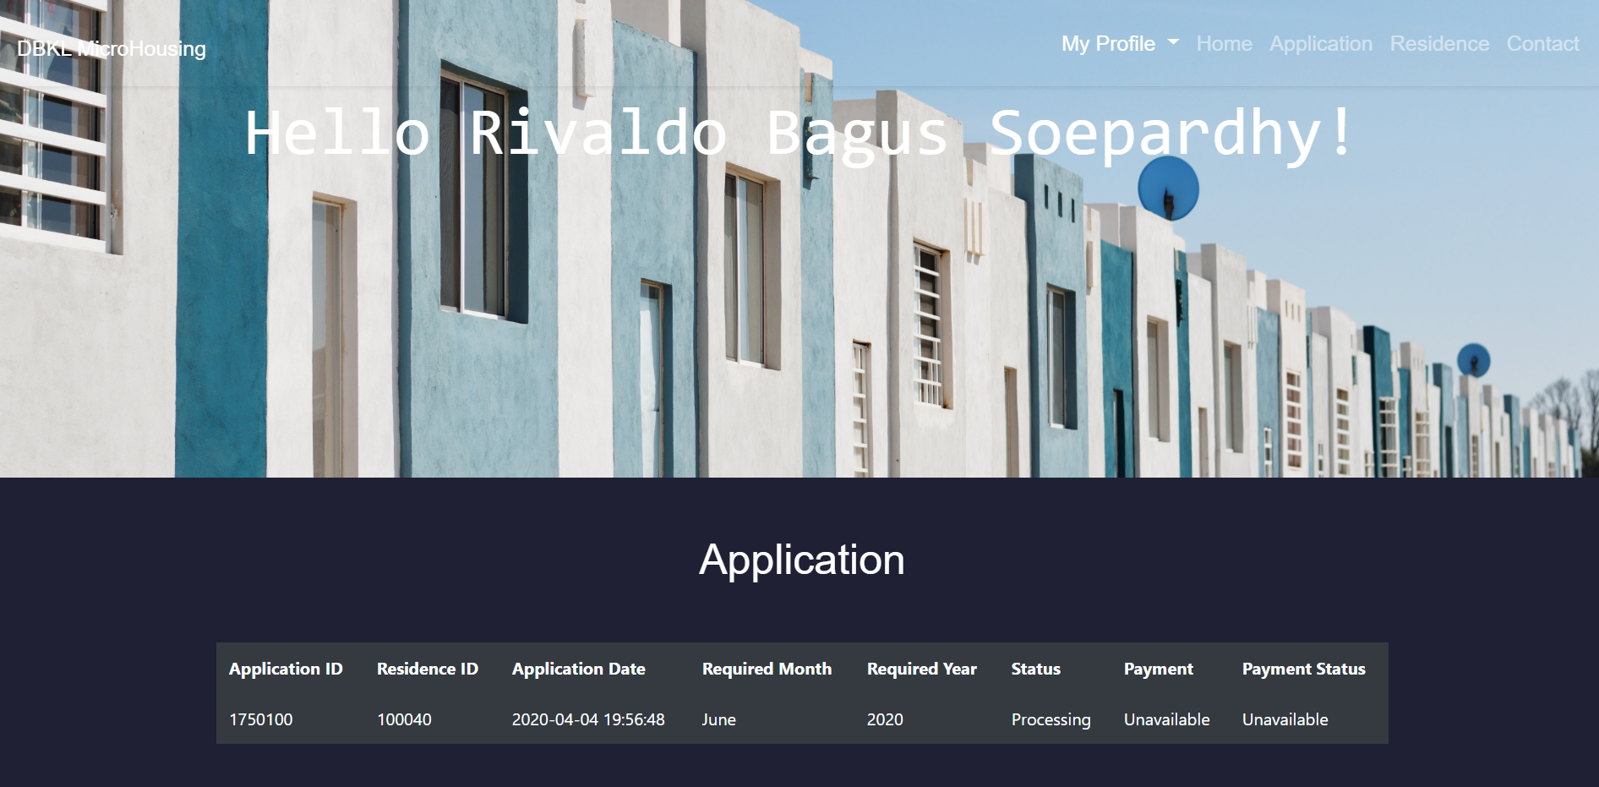

For all the function above, we are using route it is to handle our request in the Url and then direct the application to call a specific page / resource which is route to housing officer page and applicant page

